**Step 1:**

Write Up: This part of the project was not too bad to do, all my group had to do was use chapter 18 Forms and Fields, Brian Yu’s lecture 0, and W3 schools.

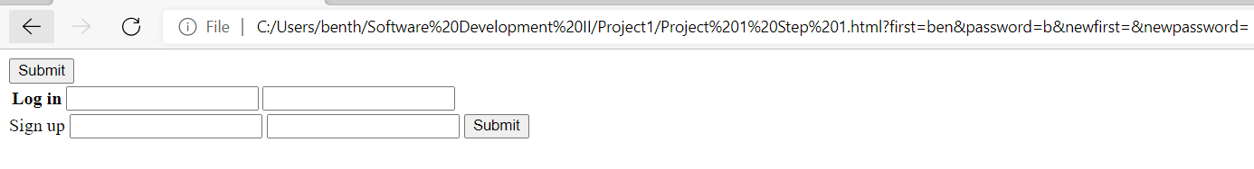

<!DOCTYPE HTML>

<html lang="en">

<head>

<title> Forms </title>

</head>

<body>

<table id="tblData">

<tr>

<form>

<th> Log in</th>

<td><input type="username" username ="name" name="first"></td>

<td><input type="password" password ="word" name="password"></td>

</tr>

<input type="submit">

</table>

</body>

<tr>

<form>

<th> Sign up</th>

<td><input type="username" username ="newname" name="newfirst"></td>

<td><input type="password" password ="newword" name="newpassword"></td>

</tr>

<input type="submit">

</form>

<body>

</body>

</html>

**Step 2**

Write up: Unfortunately my group was unable to finish this step. We read chapters 13 (The Document Object Model), 14 (Handling Events), 18 (Forms and Fields), and Brian Yu’s 6th lecture on User Interfaces in JavaScript and HTML. These resources only covered how to display the same piece of information to a webpage (ex: “hello world”). Displaying a user’s input or displayings something entered into an HTML form was not covered so my group spent hours and hours Googling. The closest we got is posted below, where the username is displayed for a split second after logging in and then disappears.

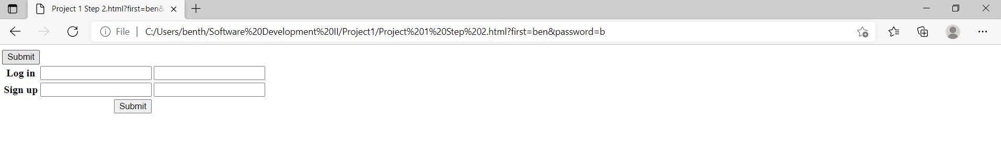

<!DOCTYPE HTML>

<html lang="en">

<head>

<script>

function displayUser() {

document.getElementById("displayarea").innerHTML = document.getElementById("user").value;

}

</script>

</head>

<body>

<table id="tblData">

<tr>

<form onsubmit= "displayUser()">

<th> Log in</th>

<td><input type="username" username ="name" name="first" id="user"></td>

<td><input type="password" password ="word" name="password" id="pass"></td>

<input type="submit">

</form>

</tr>

<tr>

<form>

<th> Sign up</th>

<td><input type="username" username ="newname" name="newfirst"></td>

<td><input type="password" password ="newword" name="newpassword"></td>

</form>

</tr>

<tr>

<td>&nbsp</td>

<td align="right"><input type="button" value="Submit" name="submit" id="submit" onClick="testVariable()"/></td>

</tr>

</table>

<table width="400px" align="right" border=0>

</tr>

<tr>

<td align="right"><div id="displayarea"></div></td>

<td align="right"><div id="displayarea1"></div></td>

</tr>

</table>

</body>

</html>

**Step 3**

Write up: Step 3 was relatively simple thankfully. As my group was trying to figure out step 2, we found out about the email input type through W3schools so implementing it was fairly easy.

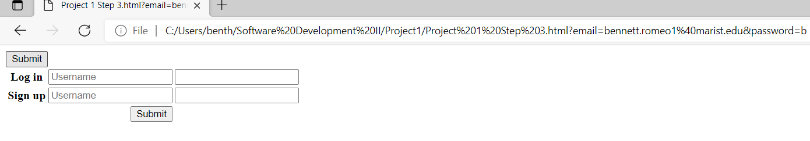

<!DOCTYPE HTML>

<html lang="en">

<head>

<script>

function displayUser() {

document.getElementById("displayarea").innerHTML = document.getElementById("username").value;

}

</script>

</head>

<body>

<table id="tblData">

<tr>

<form>

<th> Log in</th>

<td><input type="email" id="username" name="email" placeholder="Username" required></td>

<td><input type="password" password ="word" name="password" id="pass"></td>

<button onclick="displayUser()">Submit</button> <br />

<span id="spanResult"></span>

</form>

</tr>

<tr>

<form>

<th> Sign up</th>

<td><input type="email" id="username" name="email" placeholder="Username" required></td>

<td><input type="password" password ="newword" name="newpassword"></td>

</form>

</tr>

<tr>

<td>&nbsp</td>

<td align="right"><input type="button" value="Submit" name="submit" id="submit" onClick="testVariable()"/></td>

</tr>

</table>

<table width="400px" align="right" border=0>

</tr>

<tr>

<td align="right"><div id="displayarea"></div></td>

<td align="right"><div id="displayarea1"></div></td>

</tr>

</table>

</body>

</html>

**Step 4**

Write up: We were also unable to complete this step. My group spent hours with the code from David J. Malan’s Lecture 9, but we just did not understand it or his lecture. We also spent a few hours trying to use an Excel spreadsheet, but we were just as confused.

from flask import Flask, redirect, render_template, request

app = Flask(__name__)

REGISTRANTS = {}

...

@app.route("/register", methods=["POST"])

def register():

name = request.form.get("name")

if not name:

return render_template("error.html", message="Missing name")

sport = request.form.get("sport")

if not sport:

return render_template("error.html", message="Missing sport")

if sport not in SPORTS:

return render_template("error.html", message="Invalid sport")

REGISTRANTS[name] = sport

return redirect("/registrants")